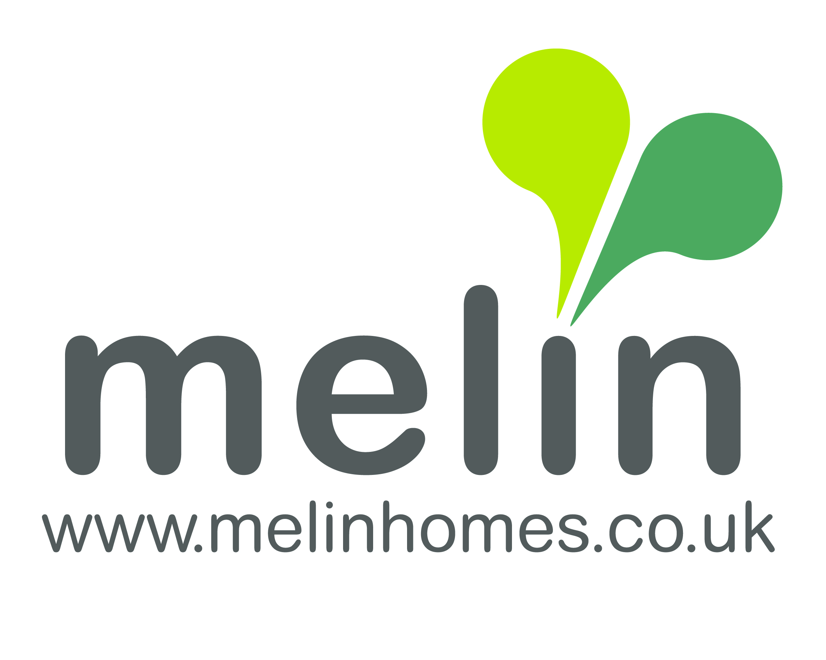

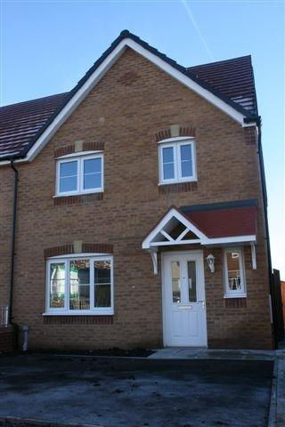
New low-cost homes for sale at Clos Odyn, Pentwyn
Do you live in or have a local connection to Torfaen?
Are you looking to own your own home?
Melin currently has 2x 2 bedroom homes for sale at our new development at Pentwyn Road for just £84,000 based on a 70/30 share.
On a shared equity basis you will purchase the property by funding just 70% of the market value and Melin Homes will provide an interest free equity stake loan for the remainder.
The loan is re-paid if chose to sell your home. Unlike shared ownership schemes, you do not have to pay rent on the percentage stake held by us.
We will require employment and landlord references. Please note that you will need to provide funds to meet the associated costs of a purchase, namely:-
- Mortgage arrangement fees
- A deposit, as required by your Mortgage Lender, usually 5% (i.e. 5% of 70%).
- Valuation and Survey fees
- Legal fees and Stamp Duty (where applicable)
- Other associated moving costs
How to apply
All applications will be subject to eligibility and affordability checks. There are two sets of criteria you must meet to be eligible for the scheme.
Stage 1 – Local connection
At stage 1, you must fulfill at least one of the following criteria:
- Live in Torfaen
- Have previously lived in the area and wish to return
- Have family connection / support in the area
- Currently employed in the local area
Stage 2 – Affordability
At stage 2, you must fulfill all of the following criteria:
- Over 18 years of age
- In permanent employment
- Not already a home owner
- Unable to afford full ownership
- Able to afford a mortgage for 70% of the property price
- Able to provide a mortgage, in principle
- Not in serious debt on an existing loan
- Have credit commitments totaling no more than 10% of your income
For more information please call Melin’s Homebuy Team on 01495 745928/ 01495 745925 or email homes@melinhomes.co.uk or Torfaen Council’s Help-to-Own Team on 01495 742631.

